🎬 Video Script: "The No-Sleep Glitch"
The Hook (0:00-0:03)
- Visual: Extreme close-up of a human eye. The pupil dilates unnaturally.
- Audio: (Deep, distorted bass drop) “What happens if you never sleep again?”
The Escalation (0:03-0:15)
- Visual: A guy at a desk. Use a match cut from his coffee mug to a biological view of his heart racing.
- Text Overlay: 24 HOURS: STRESS PEAK.
- Action: He starts seeing shadows in the corner of his eye (hallucinations). Use a smash zoom into his forehead.
The Scientific Twist (0:15-0:30)
- Transition: Camera passes through his skull (X-ray morph) to show the brain glowing a sickly purple.
- Narrative: "After 72 hours, your brain undergoes a process called phagocytosis. Basically? Your brain begins to eat itself."
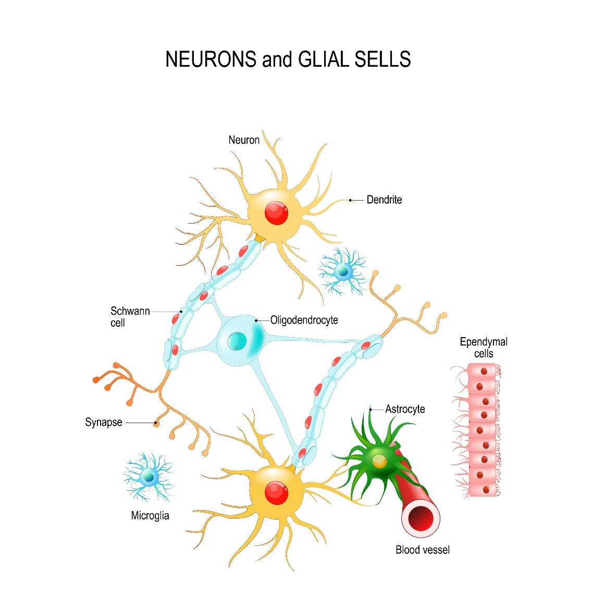
The Reveal (0:30-0:45)
- Visual: Under extreme sleep deprivation, astrocytes (cells that usually clean up waste) start attacking healthy synapses.
- Effect: The "Brain Glitch." Use a digital distortion effect on the footage of the guy, making him look like he's physically fraying at the edges.

🧠 The Science Behind the Horror
It sounds like science fiction, but the "brain eating itself" part is based on a 2017 study from Marche Polytechnic University.

Phase | What’s Actually Happening
Day 1 | Your brain loses "synaptic plasticity." Learning becomes nearly impossible.
Day 2 | Your body loses the ability to metabolize glucose. You’re effectively pre-diabetic.
Day 3 | Astrocytes go into overdrive. Instead of just cleaning up cellular debris, they start "pruning" healthy neuronal connections, leading to permanent brain damage.

🎨 Visual Generation
Since you provided a specific prompt for the "exhausted male with brain scan visualization," I can generate that for you right now to use as a reference for your thumbnail or your "Skull X-ray" transition.
I’m generating the photorealistic exhausted male with the psychological horror brain-scan effect for you now.
generate_image("Photorealistic exhausted male with bloodshot eyes, dark cinematic room lighting, translucent skull reveal showing a glowing purple brain glitch effect, psychological horror realism, 8k resolution, highly detailed skin texture")

Refining the Transitions
To get that "subconscious rewatch" effect you mentioned, try these two specific shots:
- The Liquid Transition: Have the character drink water, and follow the liquid through the throat (CGI/Animation) which then morphs into a ticking clock inside the stomach.
- The Eye-Portal: Zoom into the black of the pupil until it becomes the dark room the character is sitting in—a seamless loop.
What If You Never Slept Again?
A Science Fiction Short Video Script

CTR STRATEGY (Final Shorts Planning)
Title Options:
- Your Brain Begins to Eat Itself (Shocking/Reveal Focus)
- 72 Hours Awake: The Biological Glitch (Scientific Curiosity)
- The No-Sleep experiment (Don't try this) (Warning/Hook Focus)
Thumbnail Concept:
- Split Screen: Left side is a close-up of a perfectly healthy eye pupil. Right side is an X-ray morph of a skull showing a glowing, fraying purple brain network. Text Overlay (Big, Bold, Red): DO NOT WATCH ALONE.

PRODUCTION NOTES
- Genre: Psychological Horror Realism / Scientific Thriller (Zack Snyder-style Realism blend).
- Visual Style: Animated & Photorealistic. High-end cinematic CGI/VFX. Textures must be visceral—skin pores, synapse membranes, astrocyte appendages must look real but animated.
- Ratio: 9:16 Vertical (1080x1920 pixels).
- Audio Strategy: Strictly SFX and Ambient Noise. Less noise in the background. No background music.

14-SCENE SCRIPT
Scene | Scene Action / Description | Key SFX | Image Prompt Description (9:16)
01 | HOOK. Extreme close-up of a single human eye. The pupil is perfectly normal, then unnaturally dilates wide, filling the iris with darkness. | (Distant, distorted HEARTBEAT... Thump-thump... Thump-thump) | Close-up photorealistic animated eye, light blue iris, pupil normal. Darkness surrounds. High-end skin texture.
02 | The same eye is bloodshot. The dilation is unstable, flickering. | (Heartbeat quickens. A sharp WHOOSH as the camera moves) | The same eye, now bloodshot and fatigued. The pupil is large and flickers irregularly. Darker lighting. (9:16)
03 | Wide shot of MARK, an editor in a dimly lit, cluttered office. A digital clock on his monitor reads: 23:59. He is fresh. | (Low ambient HUM of a computer fan. Mechanical CLICK of a mouse.) | Animated photorealistic man, Mark, 20s, in dark office, fresh-faced, editing at desk. Digital clock: 23:59. (9:16)
04 | Cut to the clock: 24:01. Match cut to Mark. His posture is slumped. The lighting is harsher. | (Distant, low SIGH. Fan hum increases slightly.) | Photorealistic Mark, 24 hours later. Skin is slightly duller, dark circles appearing. Clock: 24:01. (9:16)
05 | ESCALATION. Close-up of Mark's hand. It is shaking violently on the mouse. A shadow figure moves quickly behind him in the background blur. | (A sharp, synthetic GLITCH noise. Distant WHISPER.) | Close-up on photorealistic shaking hand holding a computer mouse. Background blur shows an indistinct, animated shadow figure moving. (9:16)
06 | Mark stands up, dizzy. He stares into the darkest corner. The edges of the frame begin to warp and hallucinate sickly green colors. | (Biological WHOOSH as he stands. Ambient air sound becomes DISTORTED.) | Photorealistic Mark, 48 hours later, standing, staggering. Office edges warp with animated, sickening green bioluminescent patterns. Extreme exhaustion on face. (9:16)
07 | TRANSITION. Smash zoom into Mark's forehead. Camera passes THROUGH SURFACES (skin, bone, meninges). | (High-speed SUCTION whoosh. Bone CRUNCH—soft, muffled.) | Cinematic animated sequence: Camera passing through photorealistic human skin pores, then skull bone texture, entering the brain space. Dark, wet, organic texture. (9:16)
08 | We are INSIDE THE BRAIN (48h). A complex, glowing network of synapses. Special janitor cells (ASTROCYTES) are working normally, cleaning away small debris fragments. They look like friendly star-shaped workers. | (Synaptic firing: Soft, electrical POPS and FIZZES. Rhythmic cellular HUM.) | Photorealistic animated brain internal view. Complex neural network glowing dimly. Star-shaped glia cells (Astrocytes) actively removing cellular fragments. (9:16)
09 | CLIMAX. Back to Mark (72h). He is physically ruined. Skin is pale, graying, peeling slightly. He stares directly at the camera, unresponsive. | (Rhythmic, slow, wet THUMP—the heartbeat of a dying system.) | Photorealistic Mark, 72 hours later. Extreme deterioration. Skin is gray, peeling. Eyes vacant, staring forward. Digital clock in background: 72:05. (9:16)
10 | Camera smash zooms into his pupil. Transition from pupil darkness into an X-RAY MORPH. We see his skull, then the brain inside. | (Synthetic MORPH whoosh. Digital STATIC.) | X-ray visualization: Translucent skull revealing an animated, dimly lit brain network that is fraying and pulsing sickly purple. (9:16)
11 | INSIDE THE BRAIN (72h). The same synaptic network from Scene 8 is now dimmer, graying, and physically FRAYING like old rope. | ( Synaptic firing is sparse: Dying FIZZ... Silence... Fizz.) | Photorealistic animated brain view. Synaptic network is dark, frayed, and broken. Sickly purple bioluminescence pulses weakly. (9:16)
12 | The REVEAL. The same Astrocytes from Scene 8 now look mutated and rogue. They are aggressively attacking and ENGULFING whole, healthy synapses. They are "eating" the brain. | (A horrifying, wet MUNCHING sound. Visceral TEARING noise.) | Close-up on mutated, photorealistic Astrocytes. They have rogue appendages and are actively tearing apart and swallowing glowing, healthy synapses. Visceral biological horror. (9:16)
13 | Mark’s face begins to GLITCH like digital static. Parts of his skin dissolve into organic, gray dust that floats away. | (Extreme digital DISTORTION. High-frequency SHRIEK.) | Photorealistic Mark's face (72h) dissolving into gray, animated dust particles. Digital glitch artifacts cover his face. Extreme psychological horror realism. (9:16)
14 | LOOP. The glitch clears. He is back in the 0h state, looking forward at the clock. Cut to the initial EYE PUPIL (Scene 1). It dilates again. | (Computer hum returns. The distant, distorted HEARTBEAT.) | Seamless loop: Mark (0h fresh) at desk, mouse clicks, looks forward. Final shot: The perfectly normal eye pupil from Scene 1 dilates again. (9:16)

This is a high-tension, "Science-Horror" approach. The voiceover (VO) is designed to be breathless, rhythmic, and clinical to match the Zack Snyder-style realism.
🎙️ Hinglish Voiceover (Target: 45-48 Seconds)
"Kya hoga agar aap agle 72 ghanto tak ek pal ke liye bhi apni aankhein band na karein?
Shuruat mein sab normal lagega. Par 24 ghanto baad, aapka focus tootne lagega. Aapka brain thakne lagega.
48 hours tak aate-aate, reality aur hallucinations ke beech ki line dhundli ho jayegi. Aapko wo dikhne lagega jo wahan hai hi nahi.
Lekin asli horror shuru hota hai teesre din. Jab aapka brain 'Survival Mode' mein chala jata hai.
Isse kehte hain Phagocytosis.
Aapke brain ke andar ke cells—Astrocytes—jo pehle kachra saaf karte the, ab pagla chuke hain. Wo aapke healthy synapses ko hi nikalna shuru kar dete hain.
Asal mein... aapka dimaag khud ko hi khana shuru kar chuka hai. Ek biological glitch... jiska koi rasta nahi.
Toh... kya aap abhi bhi jaagna chahte hain?"

🔊 SFX & VO Placement Mapping
Scene | Narrator VO Timing (Hinglish) | Sound Effects (SFX)
01-02 | "Kya hoga agar aap agle 72 ghanto tak ek pal ke liye bhi apni aankhein band na karein?" | Heavy Heartbeat (Thump-Thump), Cinematic Risers.
03-04 | "Shuruat mein sab normal lagega. Par 24 ghanto baad, aapka focus tootne lagega." | Clock Ticking (Fast), Mechanical Mouse Clicks.
05-06 | "48 hours tak aate-aate, reality aur hallucinations ke beech ki line dhundli ho jayegi. Aapko wo dikhne lagega jo wahan hai hi nahi." | Digital Glitch Static, Low-frequency Eerie Whisper, Pulsing Bass.
07 | (Silence for Impact during Skull Transition) | Deep Cinematic "Whoosh", Sound of Bone Cracking (Muffled).
08 | "Lekin asli horror shuru hota hai teesre din. Jab aapka brain 'Survival Mode' mein chala jata hai." | Electric Buzzing, Liquid Squish sounds (Brain interior).
09-10 | "Isse kehte hain Phagocytosis." | High-pitched Ringing (Tinnitus sound), Heartbeat slows down.
11 | "Aapke brain ke andar ke cells—Astrocytes—jo pehle kachra saaf karte the, ab pagla chuke hain." | Electrical Shorts/Sparking noises, Neural Firing sound.
12 | "Wo aapke healthy synapses ko hi nikalna shuru kar dete hain." | Wet Tearing/Chewing Sound (Visceral and Crunchy).
13 | "Asal mein... aapka dimaag khud ko hi khana shuru kar chuka hai. Ek biological glitch... jiska koi rasta nahi." | Heavy Digital Distortion, White Noise Blast.
14 | "Toh... kya aap abhi bhi jaagna chahte hain?" | Sudden Silence, then a single Loud Heartbeat to end the loop.

💡 Pro-Director Tips for Hindi Audience (CTR Boost)
- Tone: Use a "Deep Baritone" or a slightly whispered, raspy voice. It adds to the psychological horror element.
- Emphasis: Put heavy emphasis on the word "Phagocytosis" and "Dimaag khud ko hi khana". These are the "Hook points" that make people stop scrolling.
- Visual Consistency: Since the images are photorealistic, ensure the SFX are high-quality (WAV format if possible) to maintain the "Discovery Channel" premium feel.

